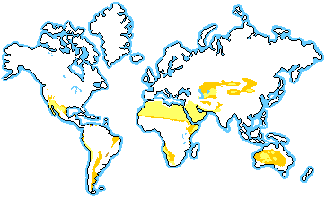
Desert Ecology 5
Location:

Description:
- Large ___________________ ______________ from_________ to ______________: 38º C to -4º C (100º F – 25º F)
- __________ ____ ___________: 25 cm (10 in) precipitation
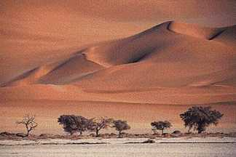
- _______ ___________: precipitation falls as rain; Mojave, Sahara
- _______ ___________: precipitation falls as snow; Antarctica

Characteristics:
- ____________ biome
- Deserts cover about _______ of the earth’s surface
- ______________________plants and animals

Survival: Plant Adaptations
- __________ ______________: in stems or roots
- ___________, __________ _______________prevents dehydration
- ______________ __________: expand to store water
- ____________ ______ ______________: plants stop growing during dry spells
- __________ ______________ ____ _____________ _______ ____________:these roots gather water deep in the soil or quickly after a rain
- _________ ____ ______ __________: this prevents dehydration; stems are green for photosynthesis
- ____________ __ __________ ___________ reflect light and prevent animals from eating

Survival: Animals Adaptations
- _________ _____________ _____________: little shelter from sun
- Many _____________________
- Many________________ animals
- Many _______________ animals

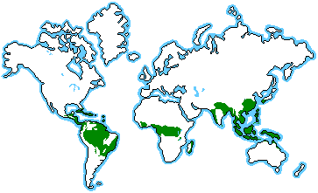
Rainforest
Location:

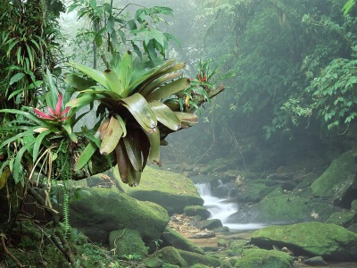
Description:
- __________ ___________: 20º C to 34º C (68º F – º 93F)
- ____________ _____ _________: 200-1000 cm (80 to more than 100 in) rain; rains year round
- __________________ ______________: close to equator: remains frost free
- _____________ _________________: cooler, near coasts (Hoh rainforest in Washington state)
Characteristics:
- Most _________________ biome
- Cover about _______ of earth’s surface
- __ of all _______________ come from rainforest plants
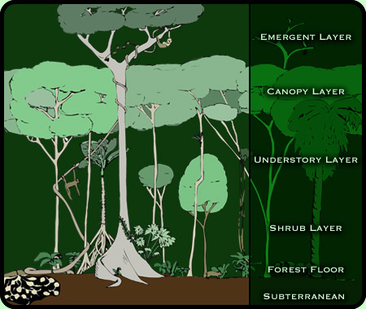
- __________ ______ ______________:
- ____________ _______________:very tall, widely spaced trees with umbrella-shaped canopies: lost of intense light
- ____________ ______________: tall trees that allow little light to penetrate; vines; most animals live here
- __________________ OR ______________ _______________: smaller trees, ferns , vines, and palms; littler light, little air movement & high humidity
- ______________ ______________:few plants because of deep shade; poor soil (nutrients quickly decomposed and absorbed by tree roots)

Survival: Plant Adaptations
- _______ ___________ and ______________ _____________:these help shed water from leaves to prevent rotting
- __________ _____________: this also helps shed water
- _______________, ________________ ________________ in __________ ____________: these leaves protect from dehydration in the intense sun
- ________________ IN ____________ _____________:these leaves help understory plants absorb light in the shade
- _________ _____________ that _________ to follow the sun: maximize light in the understory
- ___________________ (plants that grow on other plants) grow in upper canopy; orchids and bromeliads
- ________________ or _____________ ______________: anchor in shallow, wet soil
- ______________ ______________
Survival: Animal Adaptations:
- ___________________ ____________:a tail used to help climb
- ________________ _____________: blend in with brightly colored flowers
- Many __________________ live in the rainforest
- Many ____________________ animals

Ecology 6
Biome Challenge:
Directions: Place a DE by the plants and animals from the Desert and a RF by plants and animals from Rainforest.

1. Sidewinder ____
10. Saguaro ____
11. Epiphyte ____
12. Prickly Pear ____
13. Roadrunner ____
14. Vine Snake ____
15. Thorny Devil ____
16. Capybara ____
17. Three-toed sloth ____
2. Macaw ____
3. Kangaroo Rat ____
4. Jaguar ____
5. Scorpion ____
6. Fennec Fox ____
7. Howler Monkey ____
8. Poison Arrow Frog ____
9. Gila monster ____

Homework: For the Desert: Trace your hand
- On one finger, write two facts about the climate of the Desert
- On one finger, write two facts about the characteristics of the Desert
- On one finger, write two facts about the plants of the Desert
- On one finger, write two facts about the animals of the Desert
- On your thumb, write something your found interesting or surprising
- On the palm of your hand, write three things you would pack to take to the Desert (NOT Cell phone, IPAD, etc.—three things specific for the Desert)

Homework: For the Rainforest: Trace your hand
- On one finger, write two facts about the climate of the Rainforest
- On one finger, write two facts about the characteristics of the Rainforest
- On one finger, write two facts about the plants of the Rainforest
- On one finger, write two facts about the animals of the Rainforest
- On your thumb, write something your found interesting or surprising
- On the palm of your hand, write three things you would pack to take to the Rainforest (NOT Cell phone, IPAD, etc.—three things specific for the Rainforest)

