Name: ___________________________________ Date: ________________________ Period: __________

Ecological Succession
WARM-UP:
What would happen to the school grounds if we stopped mowing the grass? What plants and animals would you see…
- In 1 year?

- In 5 years?

- In 20 years?

4. In 100 years?

In 1883, the volcanic island of Krakatau in the Indian Ocean was blown to pieces by an eruption. The tiny island that remained was completely barren…like this volcanic island today

Within two years, grasses were growing. Fourteen years later, there were 49 plant species, along with lizards, birds, bats, and insects. By 1929, a forest containing 300 plant species had grown. Today, the island is blanketed by mature rain forest.
How did the island ecosystem recover so quickly?

Primary and Secondary Succession:

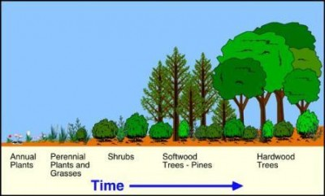

  - ________________ _______________ is a series of more-or-less predictable changes that occur in a community over time.
  - Ecosystems change over time, especially after ___________________, as some species die out and new species move in.
  - Over the course of succession, the number of different species present typically __________________

Primary Succession
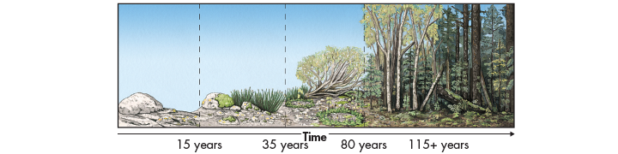

- Volcanic explosions can create new land or sterilize existing areas. Cooled lava leaves___________________
- Retreating glaciers can have the same effect, leaving only exposed_______________ behind them.
- Succession that begins in an area with no remnants of an older community is called __________________________________
- For example, in Glacier Bay, Alaska, a retreating glacier exposed_____________
- Over the course of more than 100 years, a series of changes has led to the hemlock and spruce forest currently found in the area
- Changes in this community will continue for ________________.

Primary Succession begins in a place with _____________________
Steps:
- _____________________, nothing lives
- ________________: acids break down rocks. Rock particles and the remains of dead lichens mix to start the formation of soil.
- ________________grow. Insects and other tiny organisms live in the are. Their remains add to the soil.
- ______________________. Ferns, grasses and wildflowers grow. Shrubs and small trees may grow.
5. After 100’s or 1000’s of years, a ___________________________may grow

Pioneer species
  - The first species to colonize barren areas are called ___________________________.
  - One ecological pioneer that grows on bare rock is ___________—a symbiosis between a fungus and an alga. (___________________)
  - Over time, lichens convert, or fix, atmospheric nitrogen into useful forms for other organisms, break down rock, and add organic material to form soil.
  - Certain______________, like those that colonized Krakatau early on, are also pioneer species

Secondary Succession

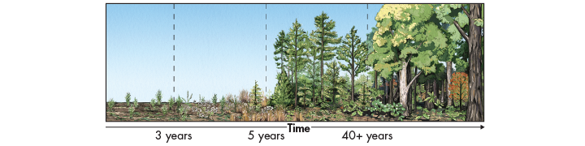

Sometimes, existing communities are not completely destroyed by disturbances. In these situations, ________________________________occurs.

- Secondary succession often follows a wildfire, hurricane, or other natural disturbance.
- We think of these events as disasters, but many species are adapted to them. Although forest fires kill some trees, for example, other trees are spared, and fire can stimulate their seeds to germinate.
- Secondary succession can also follow human activities like logging and farming.

Secondary Succession begins where _______________ is intact.
Steps:
- _____________________and other weeds start to grow
- New weeds appear. Wind and insects may bring __________________.
- Small ______________________ grow. A forest may form
- _________________________ trees may replace conifers.

Why Succession Occurs
  - Every organism changes the environment it lives in.
  - One model of succession suggests that as one species alters its environment, other species find it easier to compete for resources and survive.
  - For example, as lichens add organic matter and form ___________, mosses and other plants can colonize and grow.
  - As organic matter continues to accumulate, other ________________ move in and change the environment further.
  - Over time, more and more species can find suitable niches and survive.

Climax Communities
  - Do ecosystems return to “normal” following a disturbance?

  - Secondary succession in healthy ecosystems following natural disturbances often reproduces the original __________________________.
____________________may or may not recover from extensive human-caused disturbances

_____________________________: the final community after succession.
_________________________: well-adapted, slow-growing species in an ecosystem
Is a mature climax community always as forest?

Is this primary or secondary succession? How do you know?
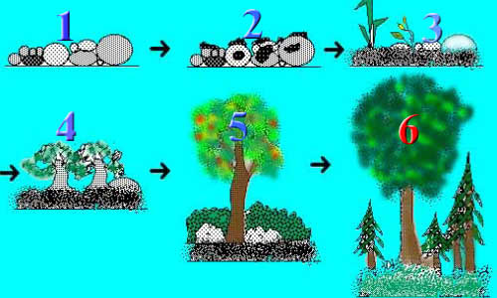

Succession after Disturbances
- Secondary succession in healthy ecosystems following ______________ disturbances often reproduces the original climax community.
- Healthy coral reefs and tropical rain forests often recover from storms, and healthy temperate forests and grasslands recover from wildfires.
- Ecosystems may or may not recover from extensive _________________ disturbances.
- Clearing and farming of tropical rain forests, for example, can change the microclimate and soil enough to ____________________of the original community. (slash and burn agriculture)

