**MCj04398510000[1]**

**The Scientific Method**

**What is the scientific method and why do scientists use it?**

1. There are two types of questions:

_____________________;

* Will my plant grow larger if I water it with coffee?
* Which will help a person lose weight quicker—Lean Cuisine or healthy
* Choice?
* Will I do better on my science test sleeping with my science book under my pillow?

_______________________:

* Why do sharks eat seals?
* How far away is the nearest planet?
* Why do some people have one blue eye and one brown eye?

The more ________________ the question, the better.

* Which drink will give you more energy?
* Which energy drink will give you more energy?
* Will Amp or Red Bull increase reaction time faster?

Step 1: ________________ lead to a _______________ or _______________

* A scientifically **______________**question you are looking to test to find the answer.

Example: Will students remember more words written on blue or green paper?

Step 2: _________________

* Gather **___________________ __________**about the topics in the question to educate the experimenter.

Example: Memory, Brain, Color

Step 3: _____________________

* What you believe the answer to the question will be.
* A possible **_________________________**
* Used to make a **_________________________**
* The prediction is often written as an

If…Then statement

If I do this Then this will happen

Will my plant grow bigger if I water with coffee?

If I water my plant with coffee , then it will grow bigger

**Independent and Dependent Variables**:

* These are the buried treasures found in the hypothesis!
* **______________________**(The one thing I can change)
* Example: feeding plant coffee
* **_____________________** (The measurement to check my guess)
* Example: The plant’s height
* Question: Will eating Wheaties for breakfast increase test scores?
* Prediction:___________________________________________________________________________________________________________________________
* Hypothesis:___________________________________________________________________________________________________________________________
* Independent:_____________________________________________
* Dependent:______________________________________________

C:\Program Files\Microsoft Office XP\Media\CntCD1\ClipArt6\j0287501.wmf

* **Hypothesis**: An educated prediction using

if and then statements.

* **Independent Variable**: The one thing I can change
* **Dependent Variable**: The measurement to check

to see whether or not my guess was correct.

Example: **If** a student studies words on green paper

**then** they will remember more words.

Step 4: _________________________

**____________________**

* The list of items you need to conduct an experiment.
* Example: 10 words, pencil, pink paper, blue paper

**_____________________________**

* The **_____________** you need to take to complete the experiment.
* **__________________________________________________**
* Be descriptive.
* Example:

1.) Seat the subject at a desk.

2.) Place a list of 10 words upside down in front

of the subject.

3.) Tell them when you say “go” they have 30

seconds to study the words.

Step 5: __________________/_________________

There are two types of data:

____________________________: height, weight, volume

____________________________: journal, written with words

Step 6: ________________________

* Compare your **________________**with the _____________________**.**
* Use the data to support your position.
* Example: My hypothesis was supported. I stated that students would remember more words written on green paper. My results showed students memorized 5.5 more words when written on green paper compared to the 1.5 written on blue, which proves my hypothesis.

Step 7: ___________________________

* **_________________** your **_____________________**!!!
  + Write a news article
  + C:\Program Files\Microsoft Office XP\Media\CntCD1\ClipArt7\j0304331.wmfWrite a lab report
  + Create a presentation
* Scientists share their work!

Real Science does not always follow the steps in the same order!

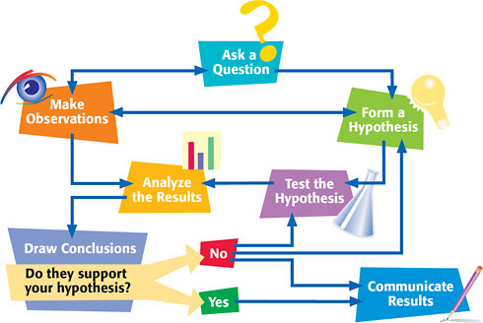

http://my.hrw.com/tabnav/controller.jsp?isbn=0030935512

The Big Question???? YOUR TURN!!!

* What is the scientific method?
* Why do scientists use the scientific method?