Name: _________________________________ Date: _______________ Period: _____
Freshwater Biome
1. Moving Water Ecosystem 2. Deeper Water Ecosystem 3.Shallow Water Ecosystem

What is an Ecosystem?
A community of living organisms and its abiotic environment:
Two factors in Ecosystems:
__________Factors: ________________ organisms that live together and interact with one another
_______________Factors: ________________ factors (water, soil, light, and temperature)

1. Moving Water Ecosystem: ____________ and ________________
Streams and Rivers
- Water can come from ____________ ice or snow
- Water can come from an underground ____________
- _________________: stream that joins a larger strea
- _______________: very strong, wide stream
________________________: how quickly the water moves
- In fast moving water—adaptations needed to keep from being washed away
Life in Rivers and Streams
- Plants at_______________
- Fish
- Clams and snails in mud
- _________________attached to rocks
- Tadpoles have suction discs

2. Deeper Water Ecosystem: _______________ and ___________________
Ponds and Lakes: Three Zones
- ______________________: close to edge, lots of sunlight
- ________________________: goes as deep as sunlight can reach
- _________________________: no sunlight; many decomposers feed on dead organisms that sink from above

Life in Ponds and Lakes
Littoral Zone
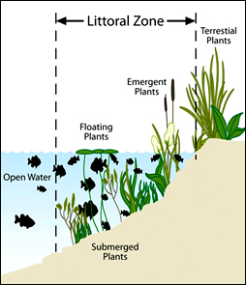
- algae
- Plants: cattails and rushes, water lilies
- Animals: snails, insects, clams, worms,
frogs, salamanders, turtles, fish, snakes
Open Water Zone
- Plankton, including algae
- Fish: bass, lake trout, other fishes
Deep Water Zone
- catfish, carp, worms, crustaceans, fungi, bacteria (decomposers)

3. Shallow Water Ecosystem: Wetlands ______________ and _______________
Wetland
- Area ____________________ or whose soil contains lots of moisture
- Important in _____________________________: soak up lots of water
- Help replenish underground ___________ ____________
Marshes
________________: treeless wetland; found in shallow areas along lakes, ponds, rivers,
and streams
Marsh life:
- Plants: grasses, reeds, bulrushes, wild rice
- Animals: muskrats, turtles, frogs, birds

Swamps
_____________: wetland with trees and vines; low areas near slow rivers; flooded part of
year
Swamp Life:
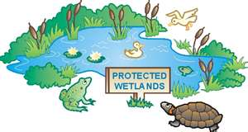
- Plants: willows, bald cypresses, oaks, vines,
poison ivy, orchids, water lilies
- Animals: fishes, snakes, birds,
alligators, turtles

