Grasslands Ecology # 3
Location: Grassland Savanna 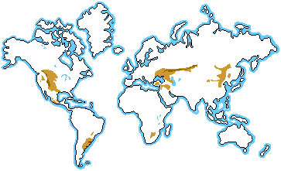
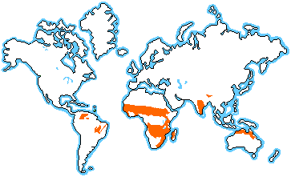
Description:
- __________ varies by ___________: -20º C – 30º C (-4º F – 86º F)
- _______________ ________________: 50-90 cm (20-35 in) precipitation
- ______________: open and continuous, usually fairly _________ areas of grass; a few trees are scattered through the grassland
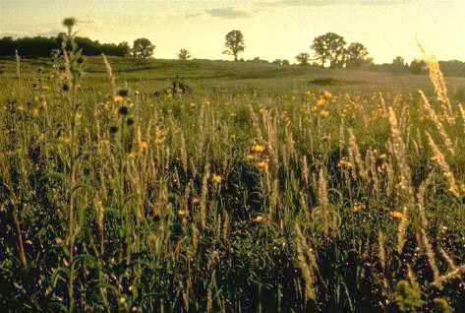
Characteristics:
- Biome found on ______________ ___________, except _______________
- usually found in ______________ of _________________ at ____________ ____________
- Prairies of the ____________ _____________ of North America;
_______________ of South America; _______________ of South Africa;
_______________ of Russia; ________________of Africa
- _________________: warm all year; scattered trees; a dry season (winter) and a wet season (summer monsoon rains)
- __________ _________ grasslands: warm, humid, more rain
- ___________ ____________ grasslands: dry with cold winters and hot summers
- ____________ _____________: grasslands have been turned into farms; they have become the “breadbaskets” of the earth

Survival: Plant Adaptations
- _________ _____________: reach deep into soil during dry season or periods of ________________; stabilize soil and prevents _______________
- __________ _____________ or have _____________ ___________: this discourages grazing
- ____________ ____________ _______________ ____: new growth not damaged by grazing animals
- _______________ ____________ ______________: some plants store water in trunk or roots
Survival: Animal Adaptations
- Home to herds of _______________ _________________
- _________________: animals move to search for water or food
- Highly ______________________ ___________ _______ ____________ to increase _____________________: animals graze at different heights, prefer different plants, or eat at different times of the day or seasons

Deciduous Forest: Our Biome
Location:
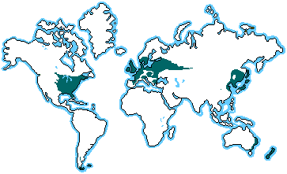
Description:
- ____________ ______ _______________: -30º C – 30º C (-22º F – 86º F); _________distinct ____________________
- _______________ _______________: 75-150 cm (30-60 in) precipitation
- ______________ ____________: broadleaf, deciduous trees (lose their leaves in winter); shrubs, mosses
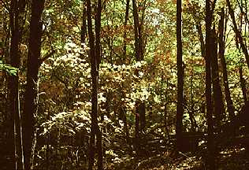
Characteristics:
- ______________ ______________ ___________ , Middle of Europe; Japan and China; southeastern Australia; New Zealand
- ____________ change color in ____________, fall off in __________, grow back in __________
- ___________ _________: fertilized by leaf litter each year
- Many deciduous forests have been lost: cleared for farmland
- The __________ ____________ allows some __________ to penetrate: this produces a rich diversity of understory plants and animals
Survival: Plant Adaptations
- ___________ ______________: protects against cold
- _______________ ____ ___________________ _______ _____________: trees lose leaves and “hibernate” during winter

Survival: Animals Adaptations
- Home to many animals
- _____________________
- Many __________________ or nut and acorn feeders

Biome Challenge:

Directions: Place a DF by the plants and animals from the Deciduous Forest, a SA by the plants and animals from the Savanna, and a GR from plants and animals from Grasslands.

1. Zebra ____
2. Oaks, hickory, maple ____
3. Raccoon ____
4. Kangaroo ____
5. Buffalo/Bison ____
6. Gray squirrel ____
7. Wildebeest ____
8. Baobab ____
9. Black bear ____
10. Lions ____
11. Prairie wildflowers ____
12. Giraffes ____
13. Song Birds ____
14. Gazelle ____
15. Black-footed ferret ____
16. Elephants ____
17. Prairie dogs ____

Ecology 4
Homework: For the Grassland: Trace your hand
- On one finger, write two facts about the climate of the Grassland
- On one finger, write two facts about the characteristics of the Grassland
- On one finger, write two facts about the plants of the Grassland
- On one finger, write two facts about the animals of the Grassland
- On your thumb, write something your found interesting or surprising
- On the palm of your hand, write three things you would pack to take to the Grassland (NOT Cell phone, IPAD, etc.—three things specific for the Grassland)

Homework: For the Deciduous Forest: Trace your hand
- On one finger, write two facts about the climate of the Deciduous Forest
- On one finger, write two facts about the characteristics of the Deciduous Forest
- On one finger, write two facts about the plants of the Deciduous Forest
- On one finger, write two facts about the animals of the Deciduous Forest
- On your thumb, write something your found interesting or surprising
- On the palm of your hand, write three things you would pack to take to the Deciduous Forest (NOT Cell phone, IPAD, etc.—three things specific for the Deciduous Forest)

