Name: _____________________________________________ Date: _______________ Period: ________

**The Chemistry of Life**

**Four things all organisms need:**

1. _______________ needed for chemical reactions

2. ______________ needed to get energy from food

3. ______________ needed for energy/ATP (small energy packet)

4. ___________________ needed for resources (food, water, etc.)

**Why do we have to learn chemistry in life science???**

Chemistry is a HUGE part of life science because every living thing is made up of matter which is made up of elements….which are made of atoms…. Getting the picture here??

Air…Water….Food

**Some Definitions you gotta know!**

* __________________—anything that has ____________ and takes up ____________!
* __________________—a substance that is made of only_______ kind of ___________. An element cannot be broken downinto simpler substances

**Elements**

* **_____________ __________________**that make up everything
* Names of elements are abbreviated using __________________
* The most common elements in living things are:
  + **Carbon (C)**
  + Oxygen (O)
  + Hydrogen (H)
  + Nitrogen (N)
  + Sulfur (S)
  + Phosphorus (P)

**Even more definitions…**

* ____________—the smallest ____________________of an __________________ that still

has the _________________________or properties of that element

* Basic building blocks of all matter

For ex. Iron atoms act like iron, gold atoms act like gold, etc.

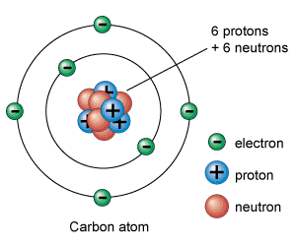

In the center, there are

* **_____________** (positive charge)
* **_____________** (neutral charge)
* Outside of the nucleus are **____________** (

**As a review…**

What two particles are found in the center of the atom? What are their charges?

What particles are floating around the nucleus in energy levels? What are their charges?

NOTE: Atoms of different elements have different _____________of __________________!

**Here’s a question for you……**

How do the electrons not fly away? Hint: Think about the charges!

**So what else do we need to know?**

Review: Where are atoms found in living things?

Atoms bond together to form _______________________in living things.

Example: Table salt is made of sodium atoms bonded to chlorine atoms:

Table salt: ____________

**Chemical Reactions**

Chemical reactions occur when ________________ are _______________or ________________ between atoms, changing one substance into another

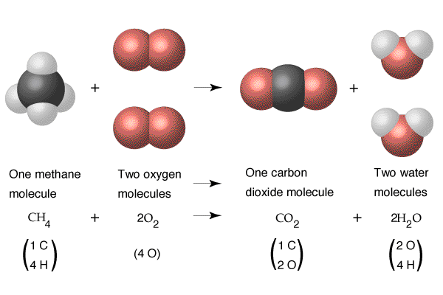

**________________________: all the chemical reactions that occur in an organism**

* Just know that a compound is made up of _________________________________and that they exist in living things!
* Can you name any compounds yourself?

**Symbols and Formulas**

* The chemical formula for the compound water is ___________
* The “2” is written in subscript—this tells us ____________________atoms of each element are

in a compound. So for water…

There are _________ atoms of ______________ (H) and ______ atom of ____________(O).

**Try to decode these formulas:**

* Tell me how many and what types of atoms are in the following compounds:

1. CH4
2. CO2
3. C6H12O6
4. NH4

**One more thing on formulas**

* If you see a big number out in front of a formula, this tells you how many molecules you have. For example,

6 H20 means that you have__________ molecules of water! How many atoms are in 6 H2O?

**Anything else I need to know?**

Yes—there are __________ kinds of compounds:

* __________________compounds contain ____________and ____________ and are usually quite ____________(many atoms)
* ______________________compounds usually do not contain carbon and are___________(few atoms

**Building blocks of life**

There are four kinds of organic compounds:

**Carbohydrates:**

**Function:**

**Examples:**

**Lipids:**

**Function:**

**Examples:**

**Proteins:**

**Function:**

**Examples:**

**Nucleic Acids:**

**Function:**

**Examples:**

**So what do I need to know?**

**Learn these definitions. You must have a basic understanding of these words in order to understand how they relate to life science. How’s that for your first chemistry lesson??**